|  |  |
| --- | --- |
|  | **FPT ACADEMY INTERNATIONAL**  **FPT – APTECH COMPUTER EDUCATION** |

**Centre Name: ACE-HCMC-2-FPT.**

**Address: 590 Cach Mang Thang 8, District 3, Ho Chi Minh City, Viet Nam.**

**LA IMPERIAL**

|  |  |  |
| --- | --- | --- |
| **Supervisor.** | Mr. Nguyen Phat Tai | |
| **Batch.** | T1.2106.E1 | |
| **Group.** | Group 7 | |
| **Serial No.** | **Enrollment Number** | **Student Name** |
| 1. | Student1331931 | Vu Duc Thinh |
| 2. | Student1320496 | Vu Minh Chau |
| 3. | Student1318427 | Nguyen Trung Hieu |

Month 09 Year 2021

**This is to certify that**

**Mr.:**

Vu Duc Thinh

Vu Minh Chau

Nguyen Trung Hieu

**has successfully designed & developed**

eProject: La Imperial website

**Submitted by: Vu Duc Thinh**

**Date of issue: 11-Oct-2021**

**Authorized Signature: Thinh**

**TABLE OF CONTENTS**

ACKNOWLEDGEMENT 6

SYNOPSIS 6

PROBLEM DEFINITION 6

CUSTOMER'S REQUIREMENTS SPECIFICATIONS (CRS) 6

Business/Project Objective: 6

Hardware/ Software Requirements: 7

SCOPE OF THE WORK (IN BRIEF) 8

Architecture and design of the system 9

Diagram of the website 10

TASK SHEET REVIEW 1 11

SITE MAP 12

MOCK OF THE WEBSITE 13

**1.** **HOMEPAGE** 13

**2.** **PRODUCTS** 14

**3.** **BRANDS** 15

**4.** **COMPARE** 16

**5.** **CONTACT US** 17

**6.** **ABOUT US** 18

TASK SHEET REVIEW 2 19

WEBSITE DESCRIPTION 20

**1.** **HOME PAGE:** 20

**2.** **PRODUCTS:** 21

**3.** **BRANDS:** 24

**4.** **COMPARE PAGE:** 27

**5.** **CONTACTUS PAGE:** 28

**6.** **ABOUTUS PAGE:** 29

TASK SHEET REVIEW 3 36

# ACKNOWLEDGEMENT

Regarding to the La Imperial project, we Group 7 would like to express our deepest appreciation to our teacher, Mr. Nguyen Phat Tai for his support and enthusiasm. It would not have been completed without his wise advices throughout the process of doing it. The outcome is also the proof of the hard work and effort of all the members of the group. We believe that it still needs to be improved since this is the very first project that we have participated so far and we are looking forward to receiving all the comments. La Imperial website project is certainly a remarkable milestone in our carriers of pursuing the dream of becoming professional developpers. Last but not least, we share this goal with our families for all the unconditional love and motivation that they have given to us.

# SYNOPSIS

La Imperial is into selling Appliances. Company has been selling these products for last 20 years. They have a wide range of Appliances. The company advertises by distributing the pamphlets, advertising on television and so on. Due to rapid development in internet field, the company decides to launch a website where people will get all the information about the various products available with them easily.

# PROBLEM DEFINITION

The Web site is to be created based on the following requirements.

1. Home Page should contain logo of the site with proper sections and details of Appliances with suitable images.
2. The site should display a menu which will contain the options for brief introduction about the various appliances available, location of the shop and any other information if required.
3. The information should be categorized according to the brand names of the products like if a User wants to see only “HAIER” products or any other companies products then he/she can click on a Link/button/menu etc and can see only that Brand products.
4. Another category option for different appliances, like ‘Washers & Dryers’ etc. should be created and accordingly the products should be listed.
5. When a user selects any particular brand, a list of products for that brand will be displayed
6. A brief summary of features of individual products should be displayed on the Web Page along with the product but detailed Features should be stored in Individual Word documents which can be downloaded or viewed by the User who wishes to see the same.
7. The user should also be able to compare the various products of different as well as similar brands.
8. There should be a “Contact Us” page which will have the Address of the Company which is as follows and the mail address which when clicked will invoke the local mail client from where they can send an email. Address of the Company should be displayed using GeoLocation API (eg. GoogleMaps).

# CUSTOMER'S REQUIREMENTS SPECIFICATIONS (CRS)

**Client: LA IMPERIAL**

### Business/Project Objective:

The Objective of this program is to give a sample project to work on real life projects. These applications help you build a larger more robust application.

The objective is not to teach you JavaScript/Dreamweaver but to provide you with a real life scenario and help you create basic applications using the tools.

You can revise the chapters before you start with the project.

This project is meant for students who have completed the module of ***HTML5.*** These programs should be done in the Lab sessions with assistance of the faculty if required.

It is very essential that a student has a clear understanding of the subject. Students should go through the project and solve the assignments as per requirements given.

Kindly get back @ [eprojects@aptech.ac.in](mailto:eprojects@aptech.ac.in) in case of any doubts regarding the application or its objectives.

**Input to the system:**

* + - * Browsing products based on brands, type of appliances..

**Output from the system:**

* A menu that will categorize all the functions of the site.
* Display the list of available albums category wisely.
* Perform the brief comparison by showing 2 products of the same type with their details.
* Site should be able to provide brief introduction/history about the company under About Us page.
* The location of the company is in Contact Us page.
* Besides the above requirements, the site should have look and feel as per the industry standards.

**Expected delivery date:** 11-Oct-2021.

**List of deliverables:**

* + - * Document Word.
      * User Guide.
      * Source code.

### Hardware/ Software Requirements:

**Hardware**

* + A minimum computer system that will help you access all the tools in the courses is a Pentium 166 or better.
  + 64 Megabytes of RAM or better.

**Software**

* + Notepad/HTML editor.
  + Dreamweaver, VisualStudioCode.
  + IE 5.0/ Netscape 6.0.

# SCOPE OF THE WORK (IN BRIEF)

**The team has discussed and has agreed about the website layout as shown briefly below:**

1. **Homepage**: Showing brief introduction about the company and type of products that it is selling.
2. **Products**: Containing its products with their details and images categorized by type.
3. **Brands**: Containing its products with their details and images categorized by brands of the products.
4. **Compare**: Providing a clear view to the customer for brief comparison of 2 products among those on sale.
5. **Contact Us**: Showing the contact information of the company such as address, location map, mobile, fax, email.
6. **About Us**: Introducing the history, archivements and further information about the company.

# Architecture and design of the system

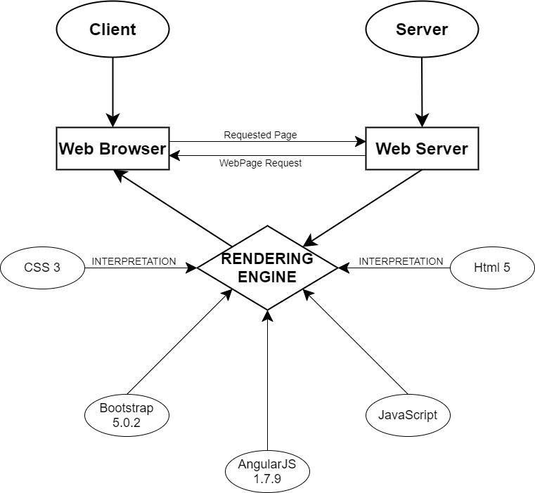

# Diagram of the website

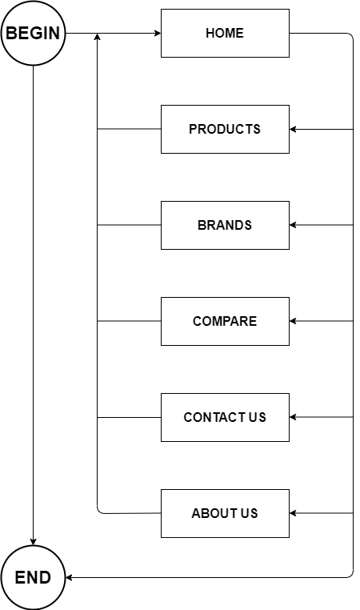



# TASK SHEET REVIEW 1

|  |  |  |  |  |  |  |  |
| --- | --- | --- | --- | --- | --- | --- | --- |
| **Project Ref. No.:**  **eP/Advertisement Portal Management**  **System/01** | | **Project Title:** | **Activity Plan Prepared By:** | **Date of Preparation of Activity Plan:** | | | |
| **Sr.**  **No.** | **Task** | **Actual**  **Start Date** | **Actual Days** | **Team**  **Mate Names** | **Status** |
| 1 | Problem Statement | La Imperial | Thinh | 12-Sep-2021 | 1 | Hieu, Chau | Completed |
| 2 | Analysis of the requirements about the website | 12-Sep-2021 | 1 | Hieu, Chau | Completed |
| 3 | The scope of the work (in brief) | 12-Sep-2021 | 1 | Hieu, Chau | Completed |
| 4 | Architecture and design of the system | 12-Sep-2021 | 1 | Hieu, Chau | Completed |
| 5 | Diagram of the website | 12-Sep-2021 | 1 | Hieu, Chau | Completed |
| 6 | Task Sheet | 12-Sep-2021 | 1 | Thinh | Completed |

|  |  |
| --- | --- |
| **Date: 20/09/2021** | |
| Signature of Instructor:  **Mr. Nguyen Phat Tai** | Signature of Team Leader:    **Mr.Vu Duc Thinh** |

# SITE MAP

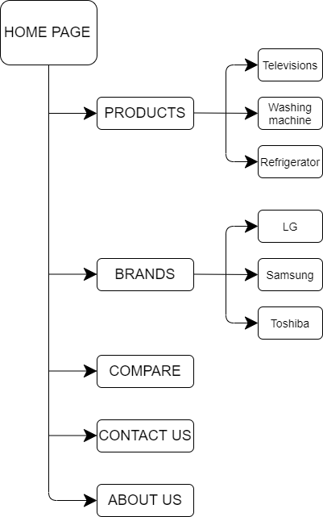

# MOCK OF THE WEBSITE

1. **HOMEPAGE**

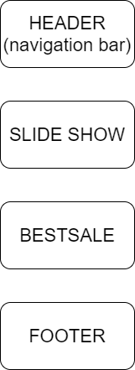

1. **PRODUCTS**

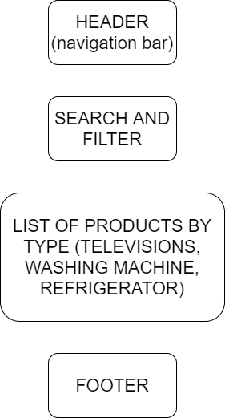

1. **BRANDS**

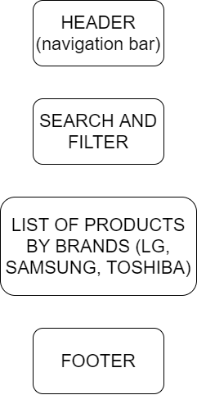

1. **COMPARE**

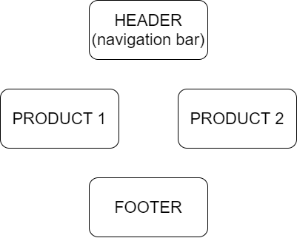

1. **CONTACT US**

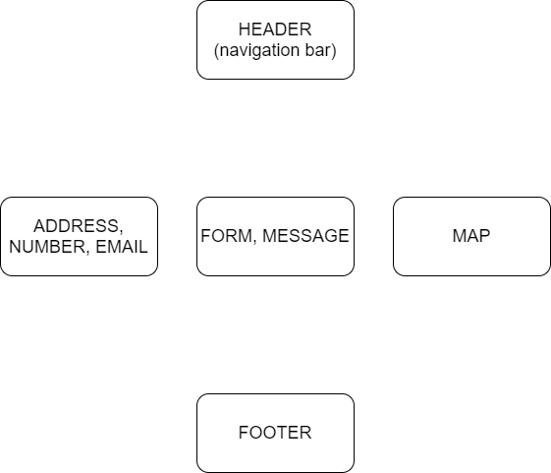

1. **ABOUT US**

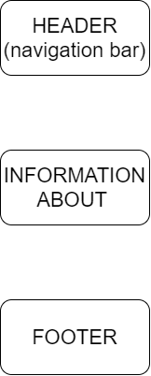

# TASK SHEET REVIEW 2

|  |  |  |  |  |  |  |  |
| --- | --- | --- | --- | --- | --- | --- | --- |
| **Project Ref. No.:**  **eP/Advertisement**  **Portal Management System/01** | | **Project Title:** | **Activity Plan Prepared By:** | **Date of Preparation of Activity Plan:** | | | |
| **Sr.**  **No.** | **Task** | **Actual**  **Start Date** | **Actual Days** | **Team**  **Mate Names** | **Status** |
| 1 | Site map | La Imperial | Thinh | 20-Sep-2021 | 1 | Thinh | Completed |
| 2 | Mock of the website | 20-Sep-2021 | 1 | Thinh, Hieu, Chau | Completed |
| 3 | Task Sheet | 20-Sep-2021 | 1 | Thinh | Completed |

|  |  |
| --- | --- |
| **Date: 27/09/2021** | |
| Signature of Instructor:  **Mr. Nguyen Phat Tai** | Signature of Team Leader:  **Mr. Vu Duc Thinh** |

# WEBSITE DESCRIPTION

1. **HOME PAGE:**

* Description

Home page displays following information:

* Slideshows of the news about La Imperial.
* Current best sale products of the week.
* Footer contains links to company’s social platforms.
* Screenshot

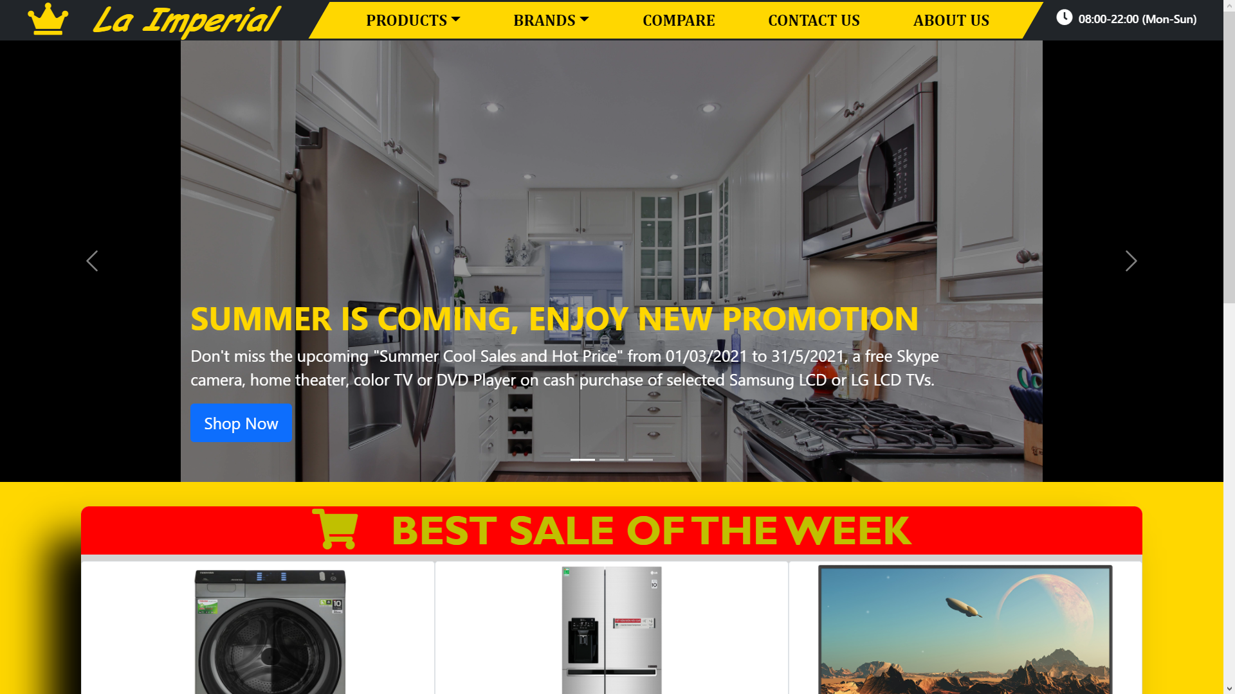

**Figure 1.1:** Homepage slideshow

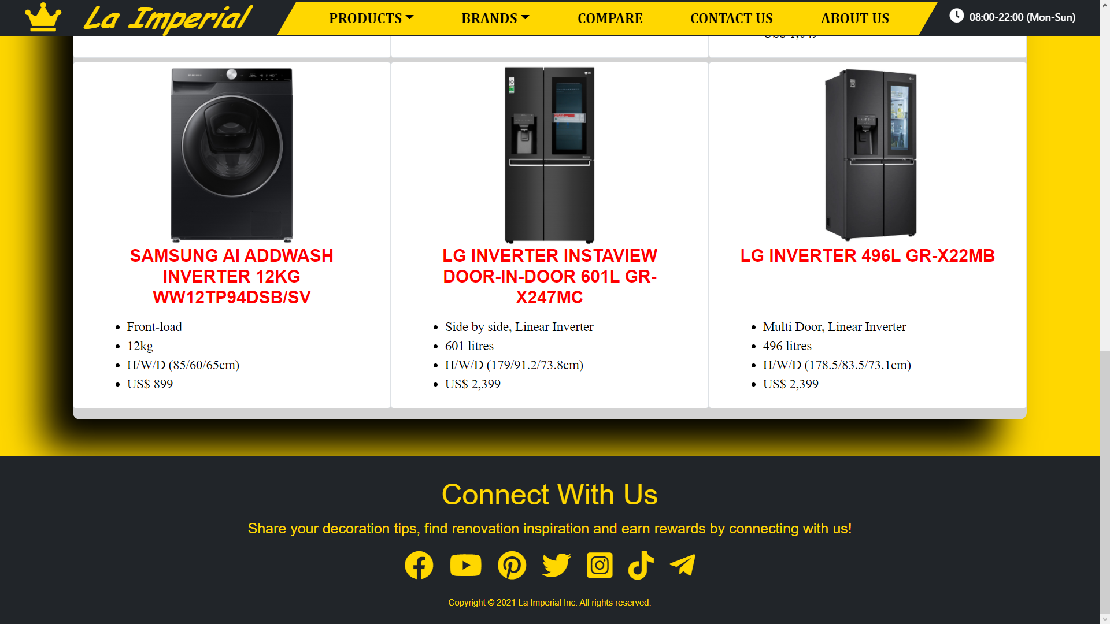

**Figure 1.2:** Footer

1. **PRODUCTS:**

* Description

This page contains various products with their information sorted by their type (television, washing machine, and refrigerator). People can also search products by their names or prices and filter them. The details products will be shown when clicking on them.

A Word document containing detailed information of each product can be downloaded by clicking a button the detailed product page.

* Screenshot

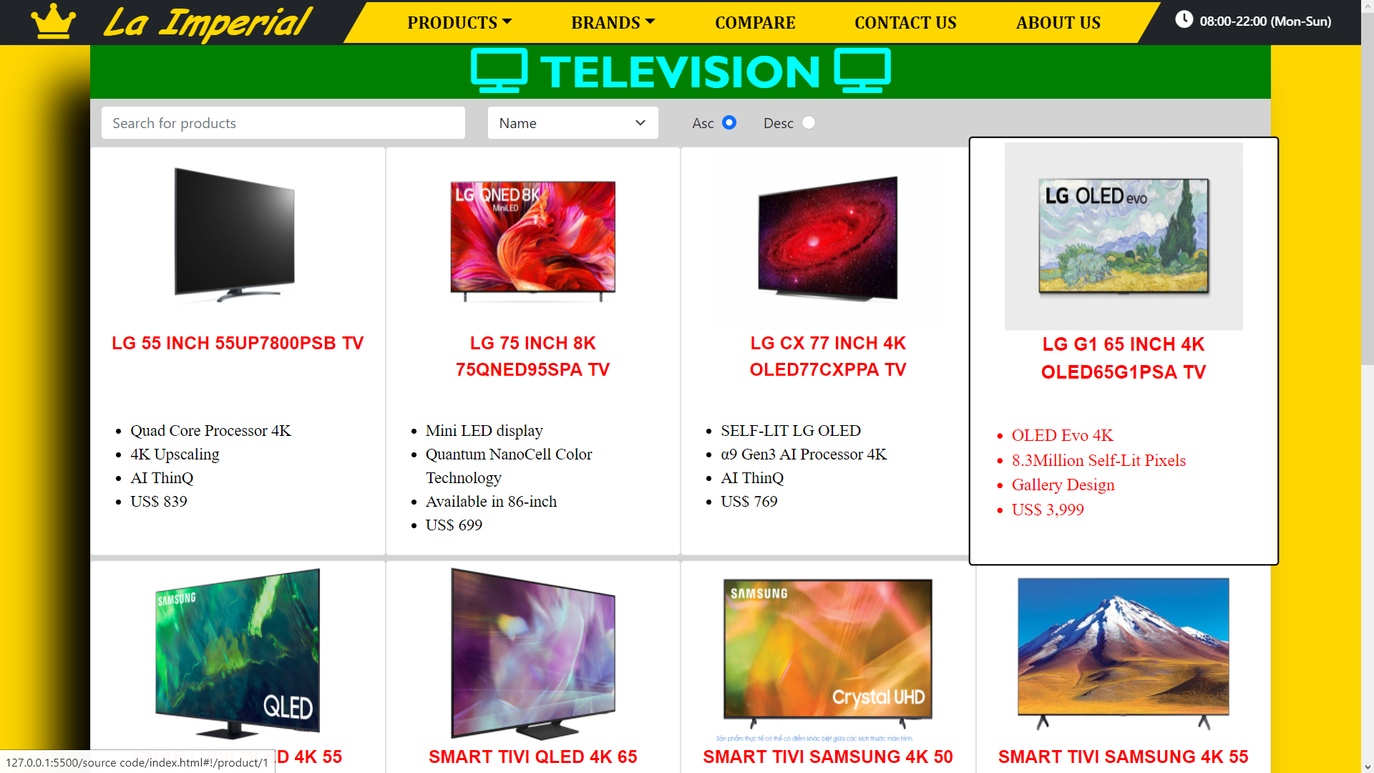

**Figure 2.1:** Television

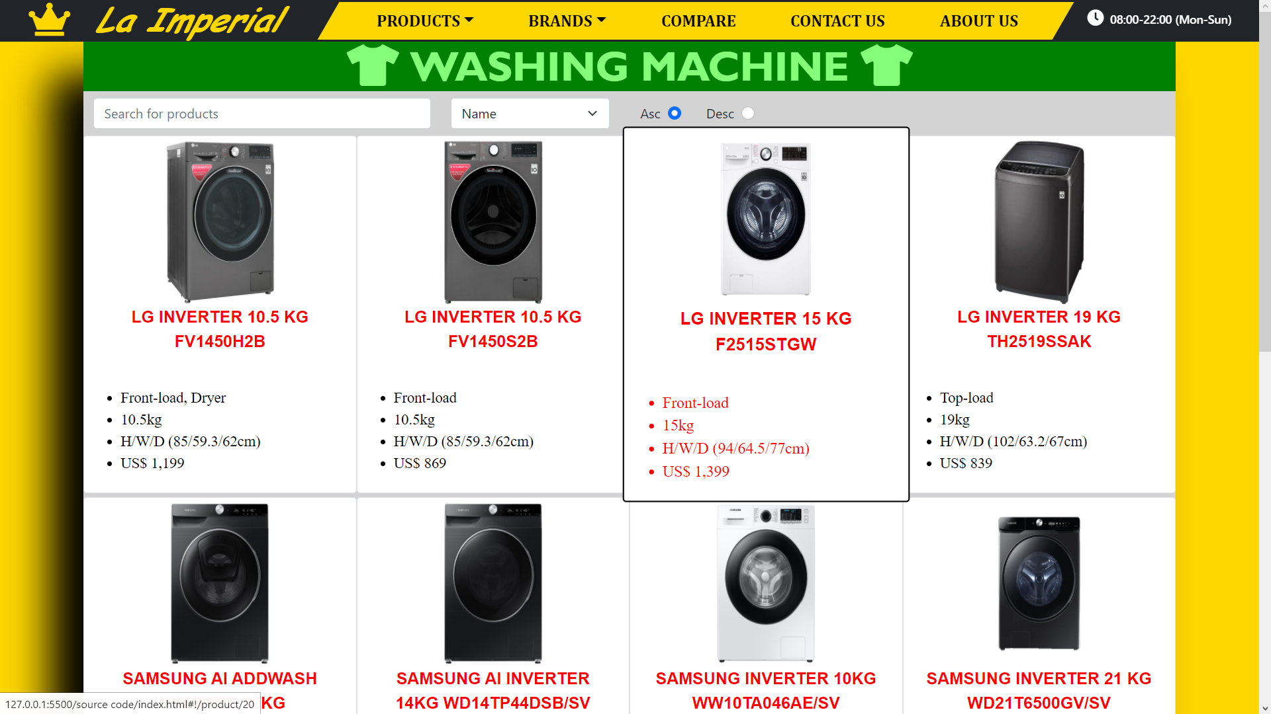

**Figure 2.2:** Washing machine

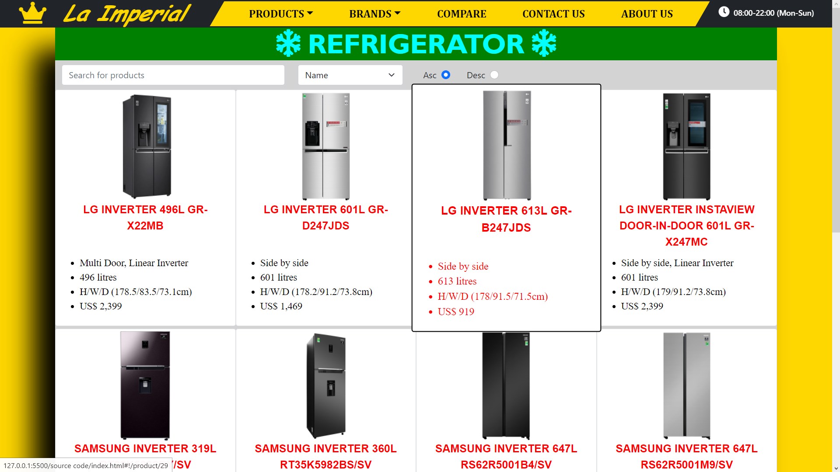

**Figure 2.3:** Refrigerator

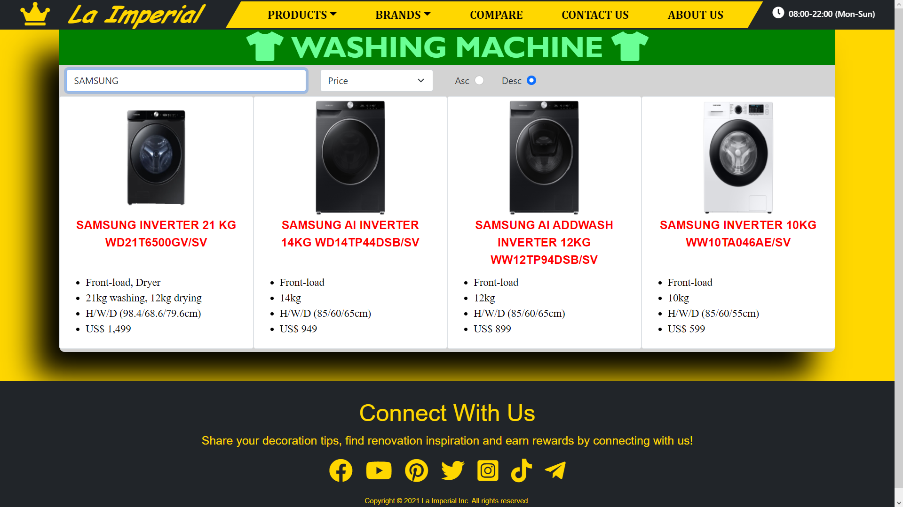

**Figure 2.4:** Search “SAMSUNG” products sorted by descending price

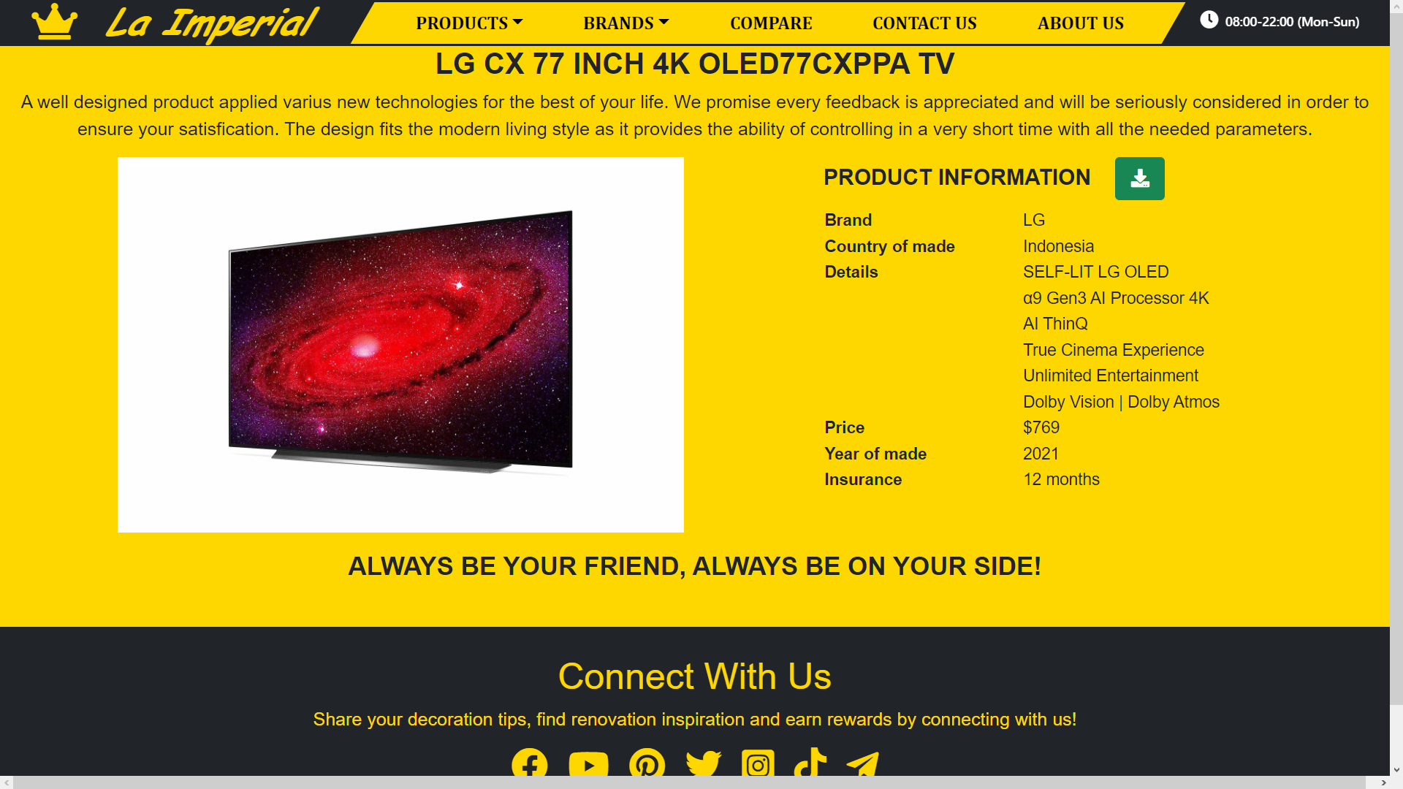

**Figure 2.5:** Product detailed information with a download button to the Word document

1. **BRANDS:**

* Description

This is also a page of products on sale with details but sorted by brands of the products (LG, Samsung, and Toshiba). People can also search the item by filtering by their names or prices. The details products will be shown when clicking on them. A Word document containing detailed information of each product can be downloaded by clicking a button the detailed product page.

* Screenshot

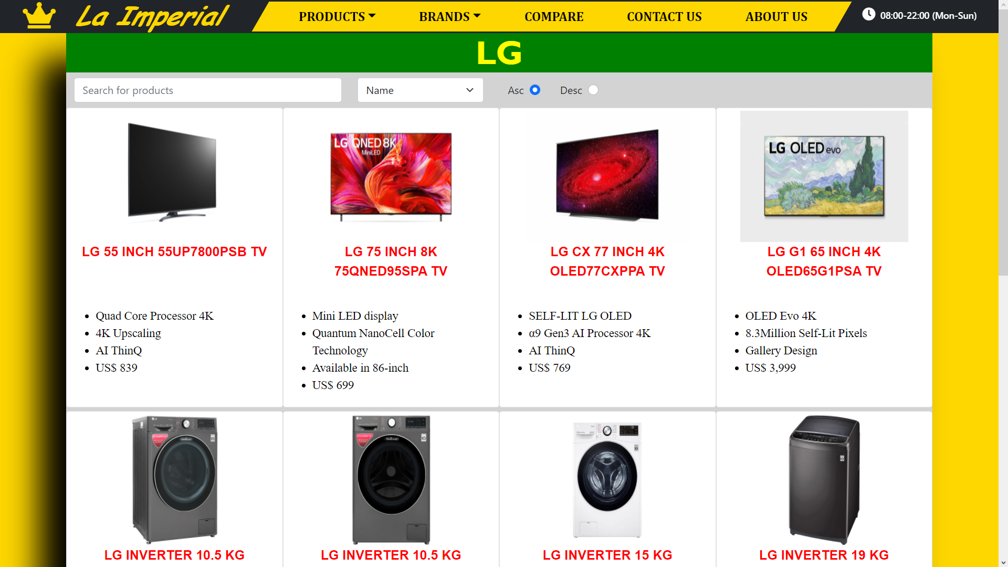

**Figure 3.1:** LG products

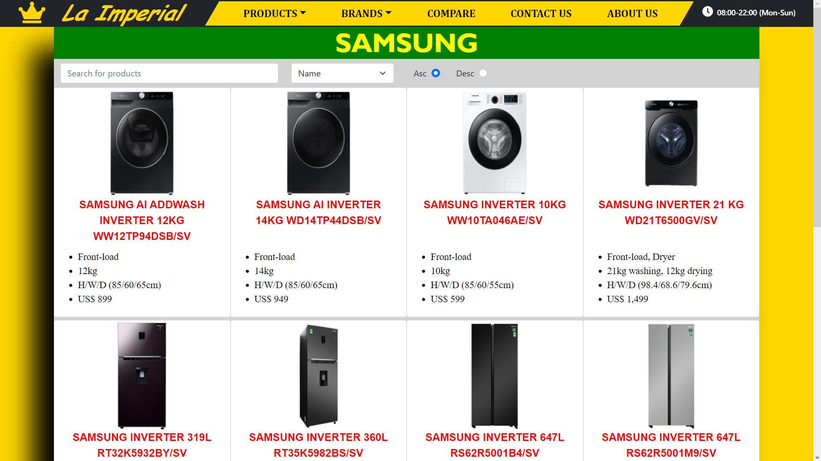

**Figure 3.2:** Samsung products

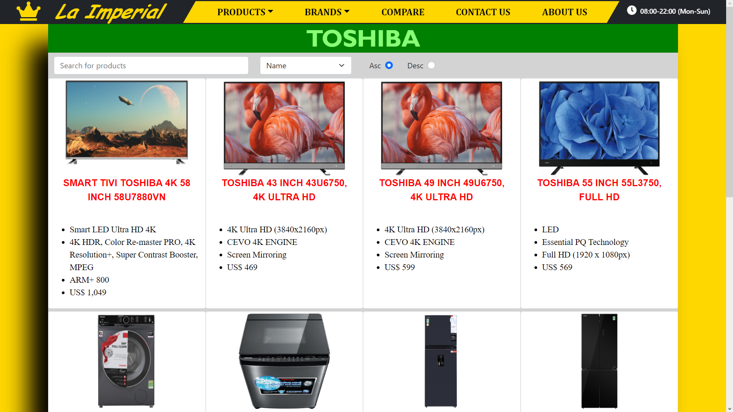

**Figure 3.3:** Toshiba products

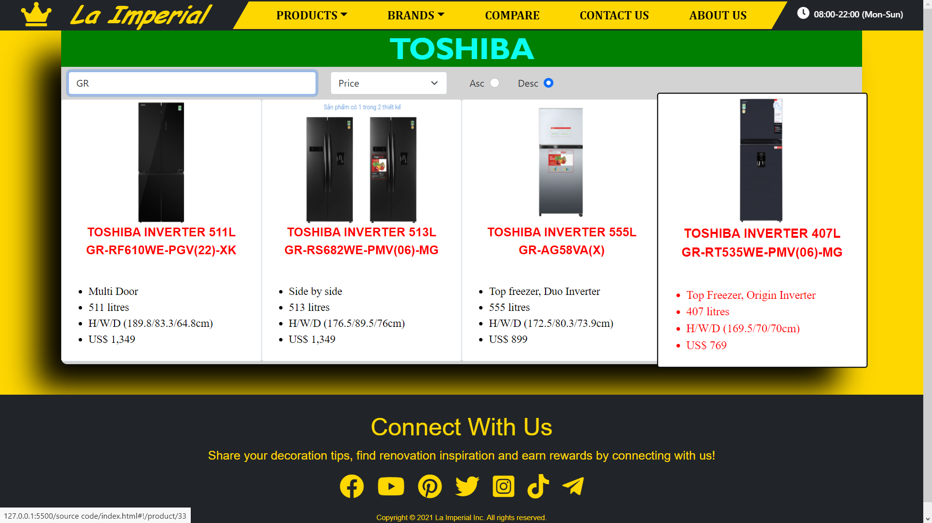

**Figure 3.4:** Search “GR” products sorted by descending price

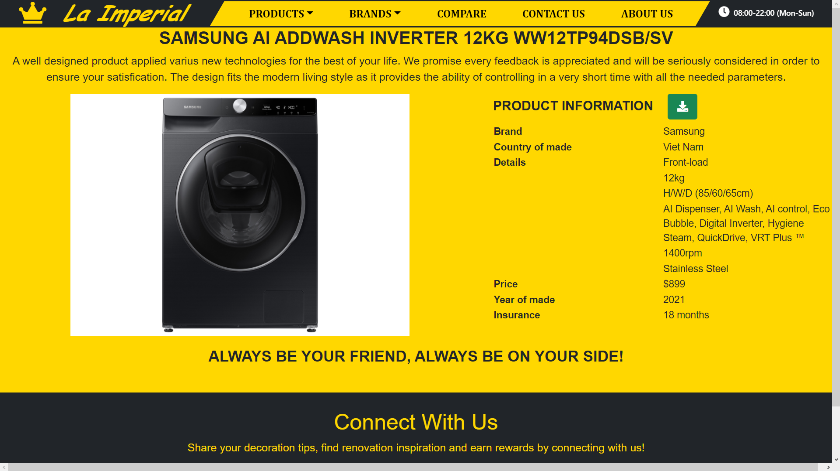

**Figure 3.5:** Product detailed information with a download button to the Word document

1. **COMPARE PAGE:**

* Description:

Customers can compare visually 2 products by selecting their names. All the details information of those products will be displayed.

* Screen shot

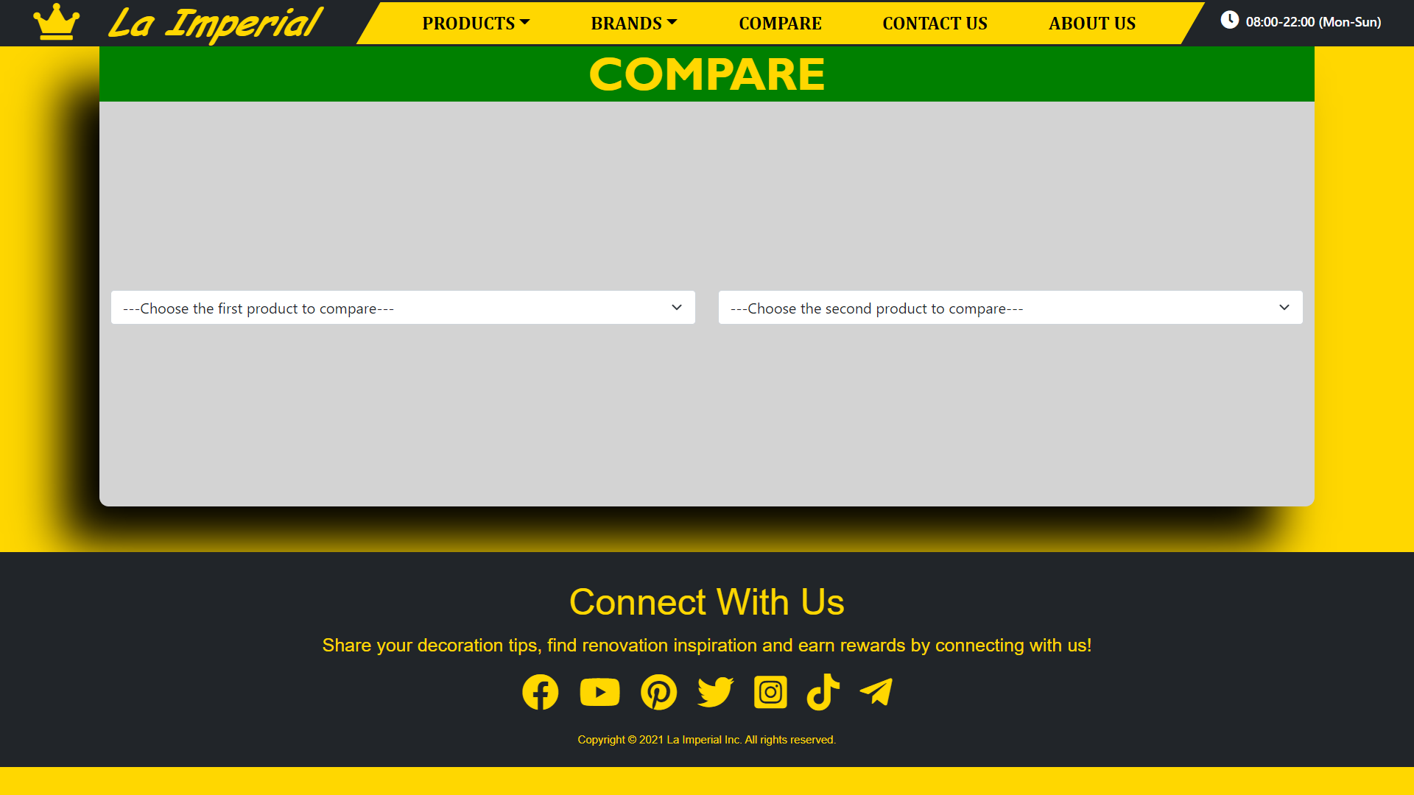

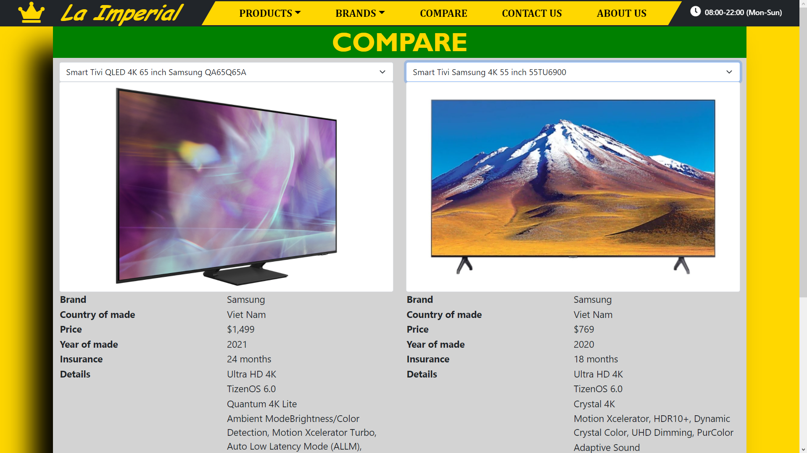

1. **CONTACTUS PAGE:**

* Description:

The information of La Imperial along with the form including the message that customer want to give the management team are given in this page. A google map about the location of the company is also provided here.

* Screen shot

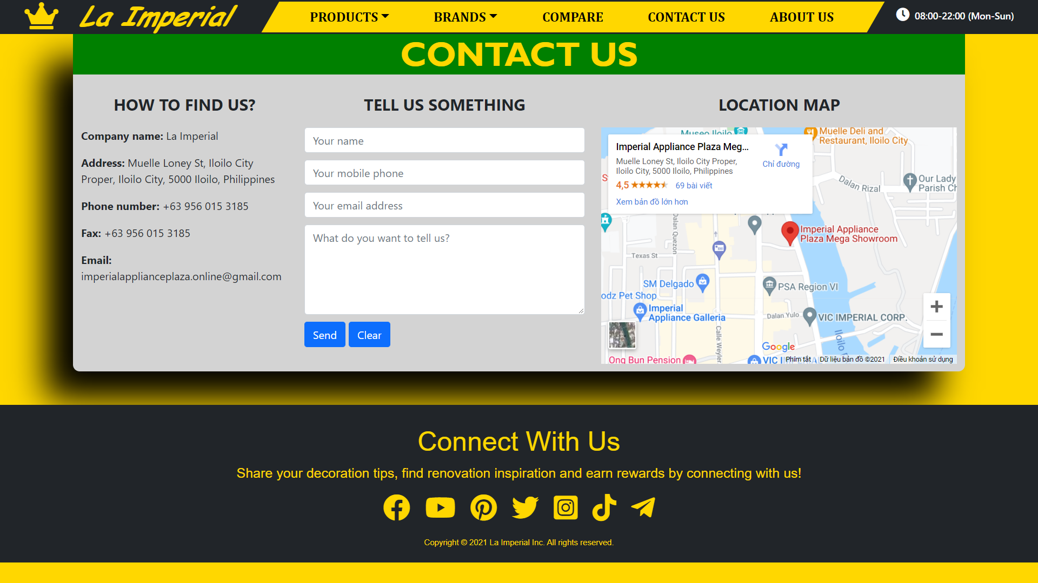

1. **ABOUTUS PAGE:**

* Description:

This is the page about the history and the scope of the company. This include the important milestones of the company’s lifetime up to now. It also shares some stories about the development of La Imperial and also the scope, the vision in the future.

* Screen shot

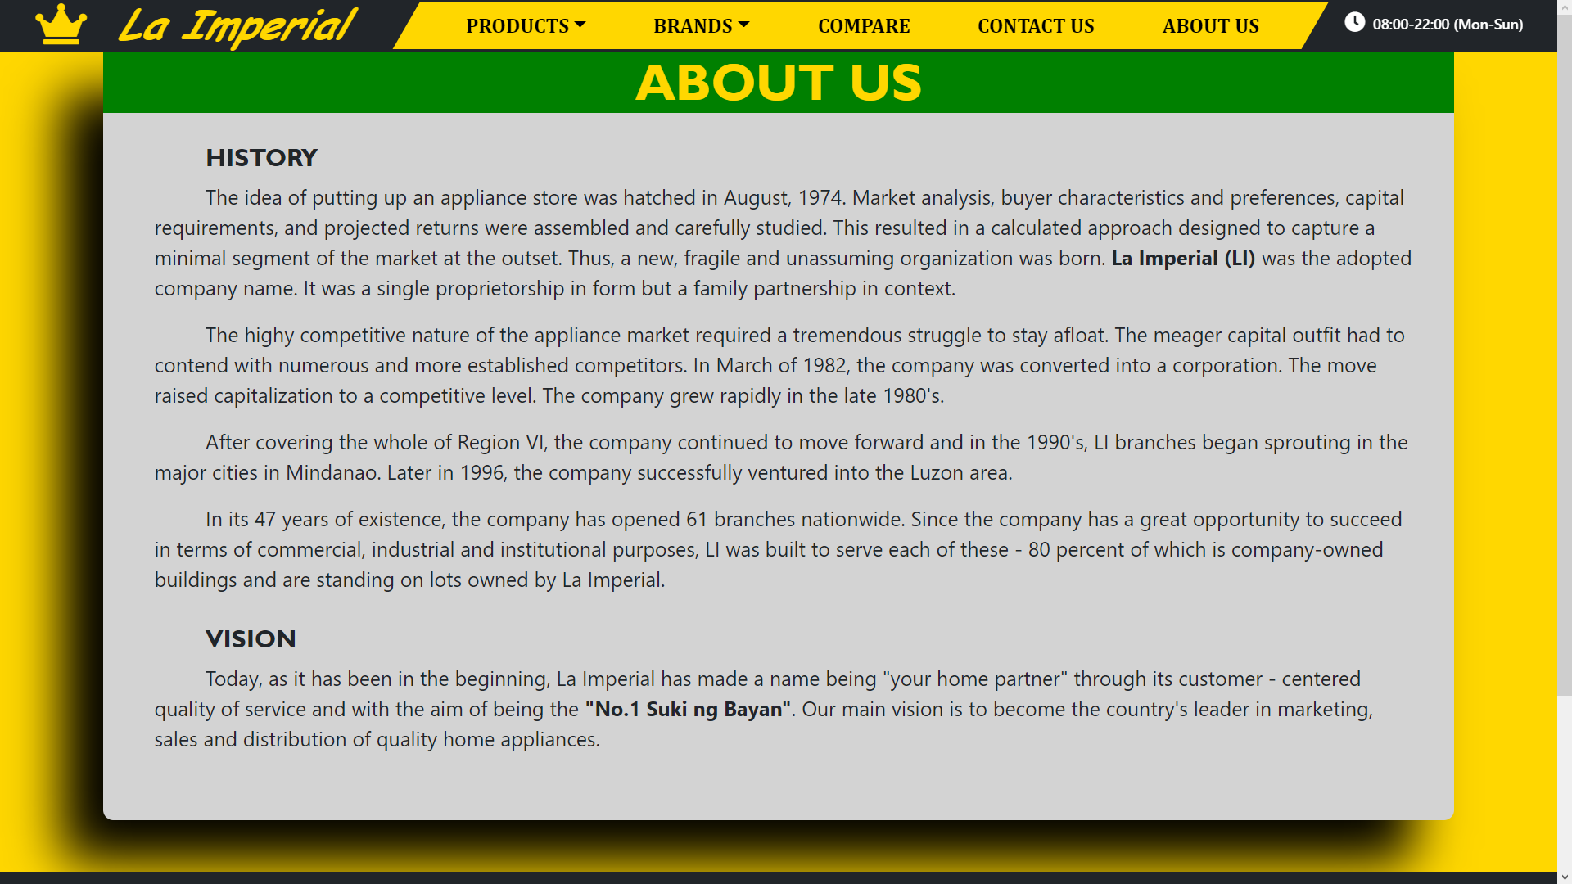

**HTML, CSS, JAVASCRIPT DESCRIPTION**

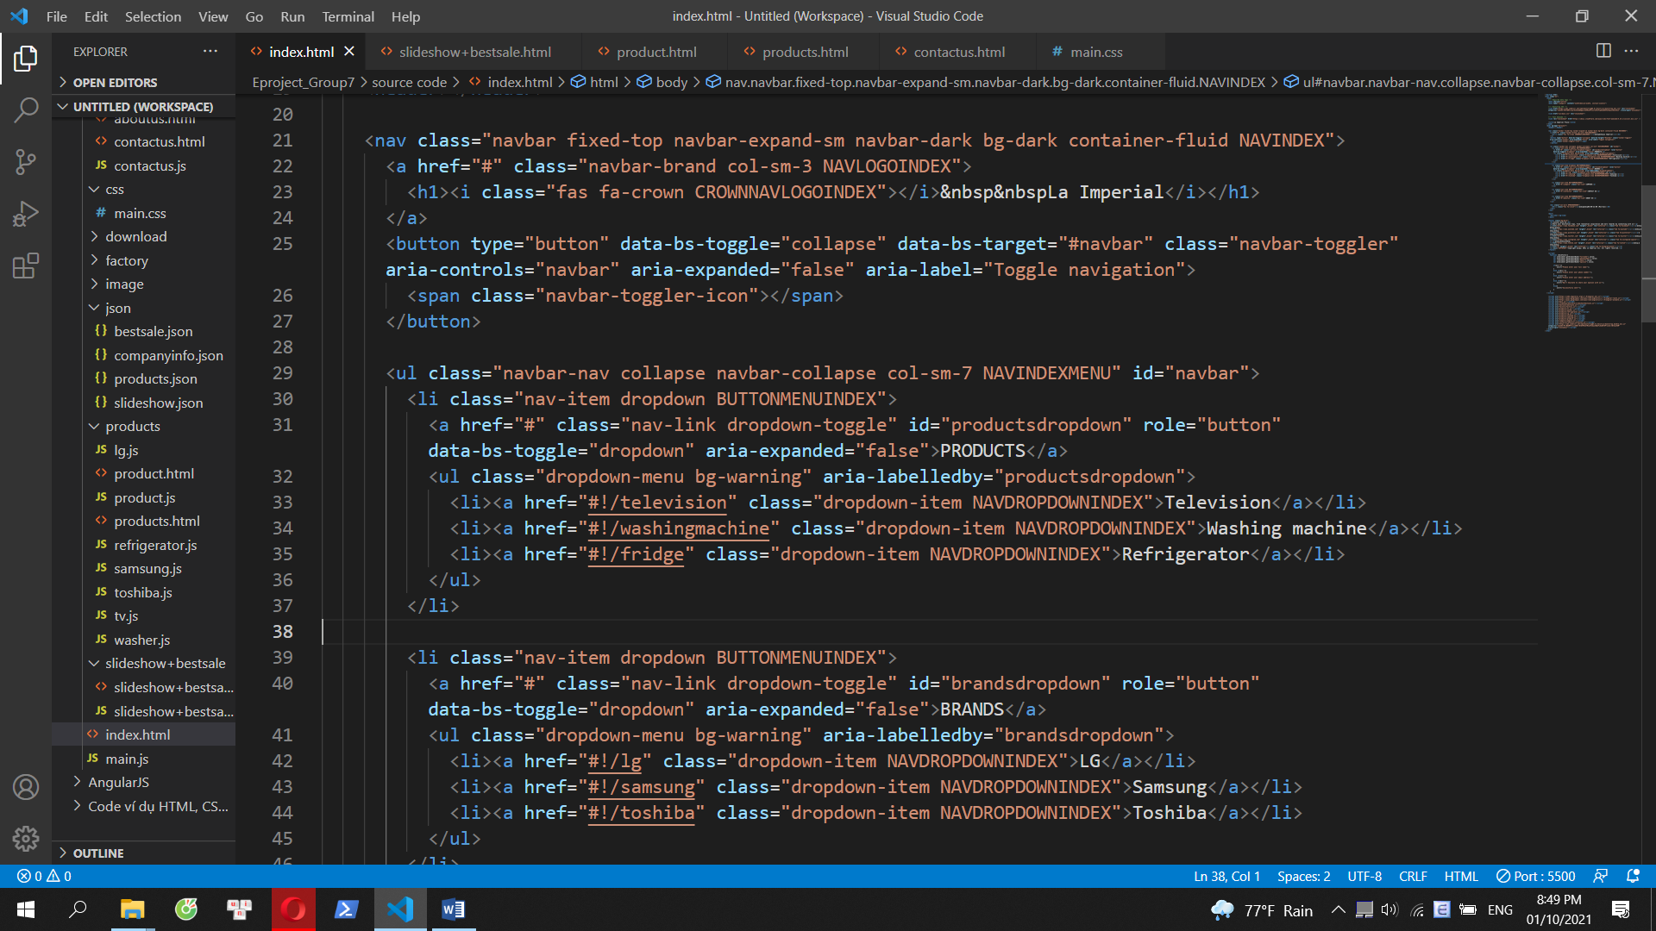

**Home page**

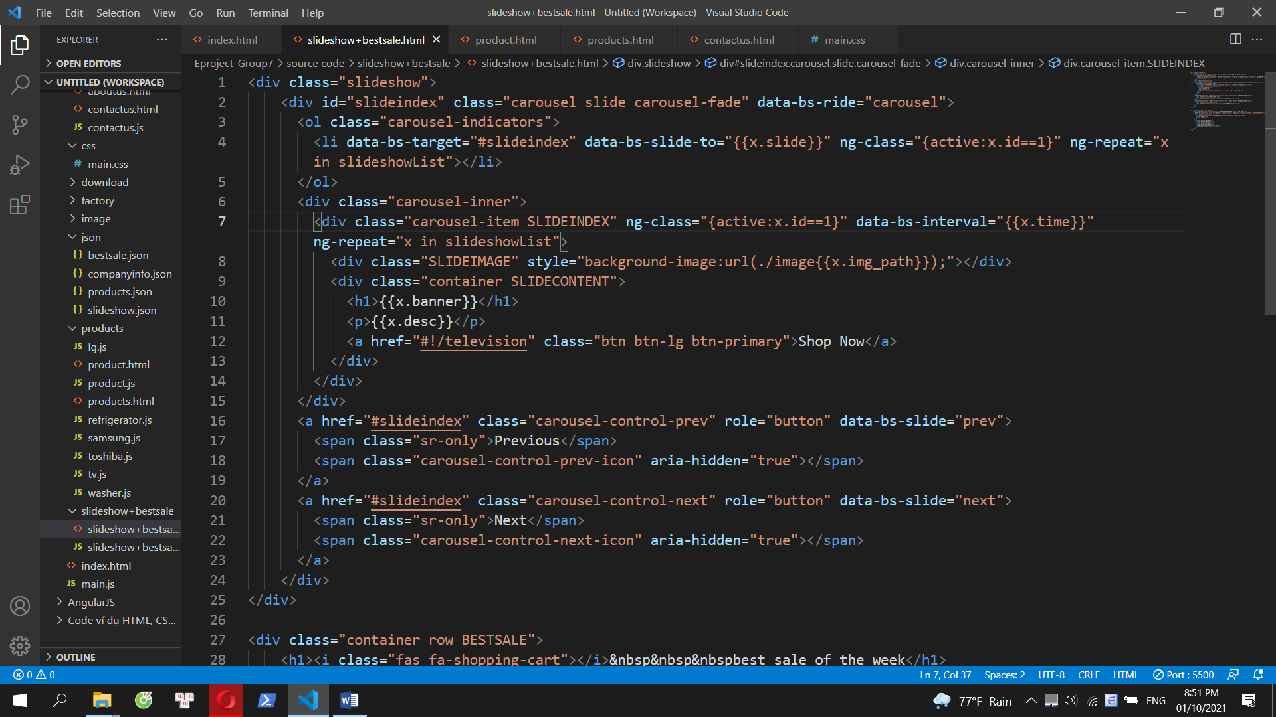

**Slideshow**

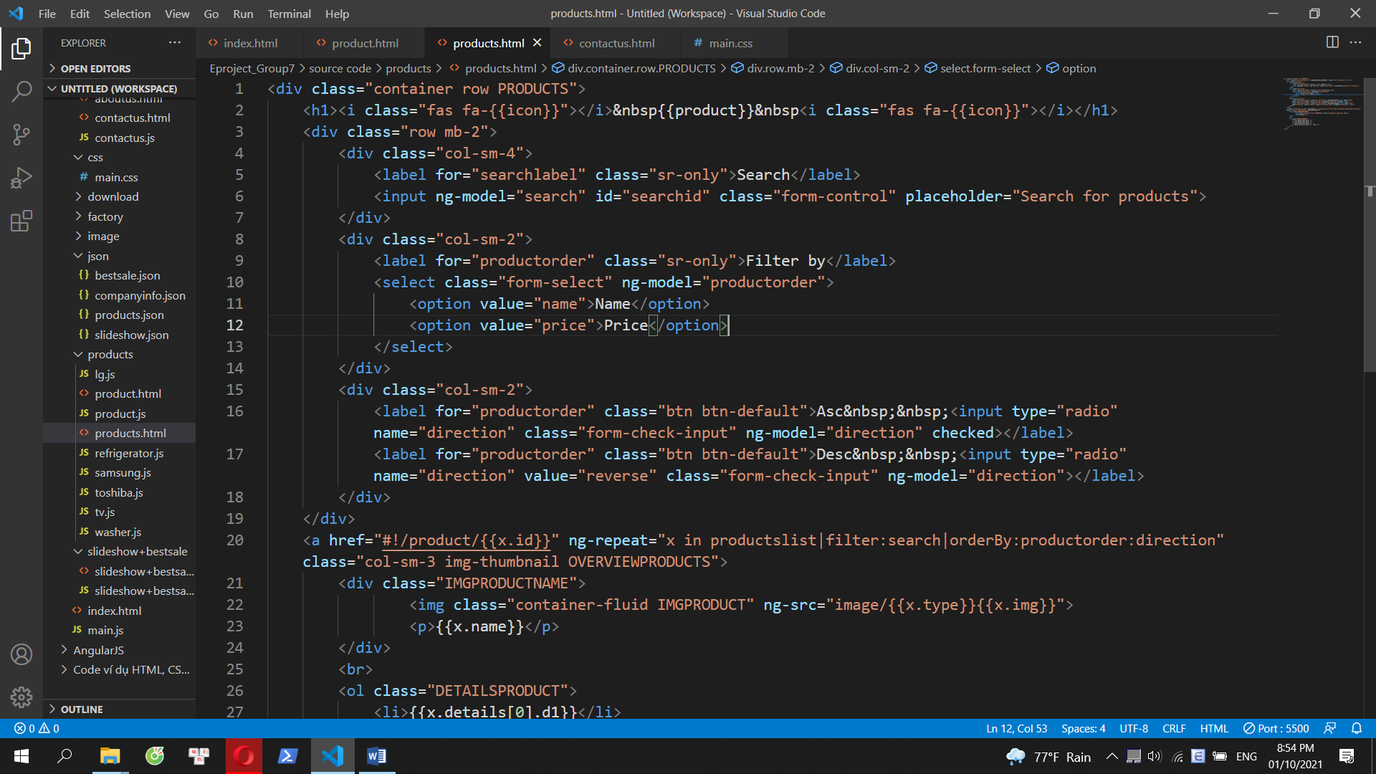

**Products page**

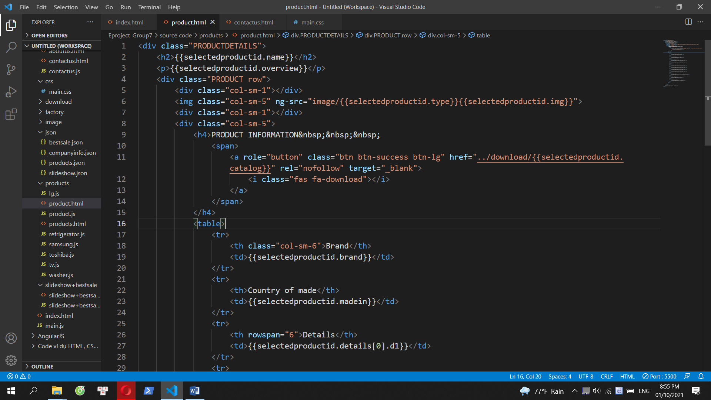

**Product details page**

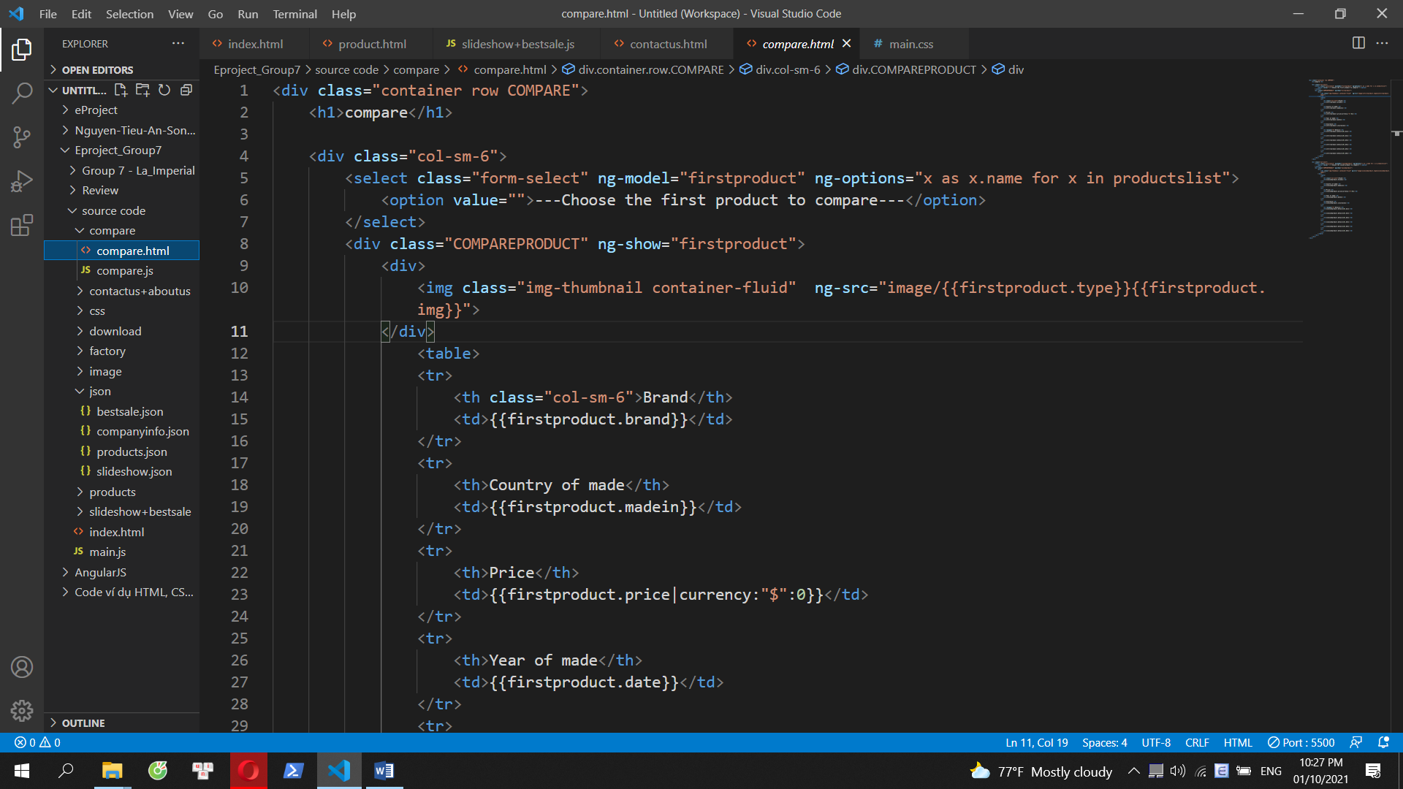

**Compare page**

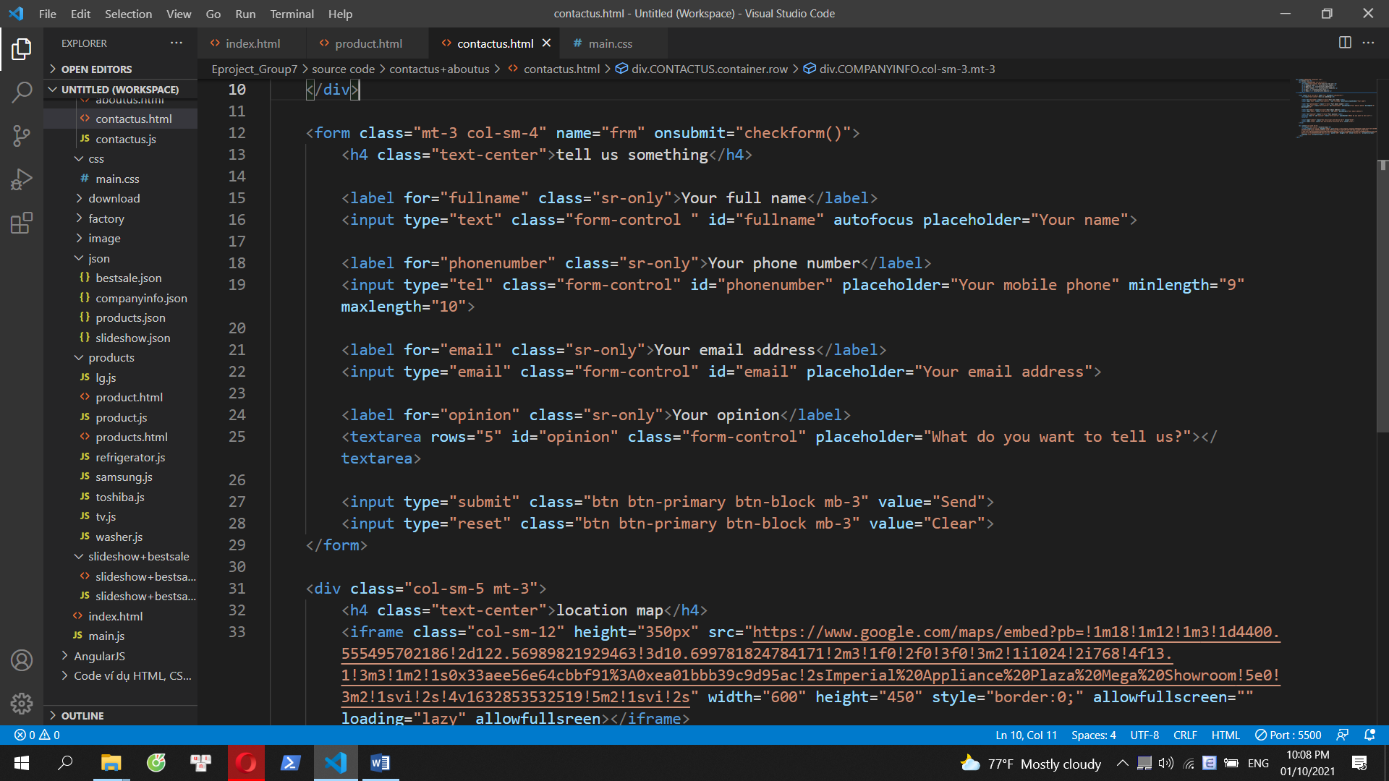

**Contact Us page**

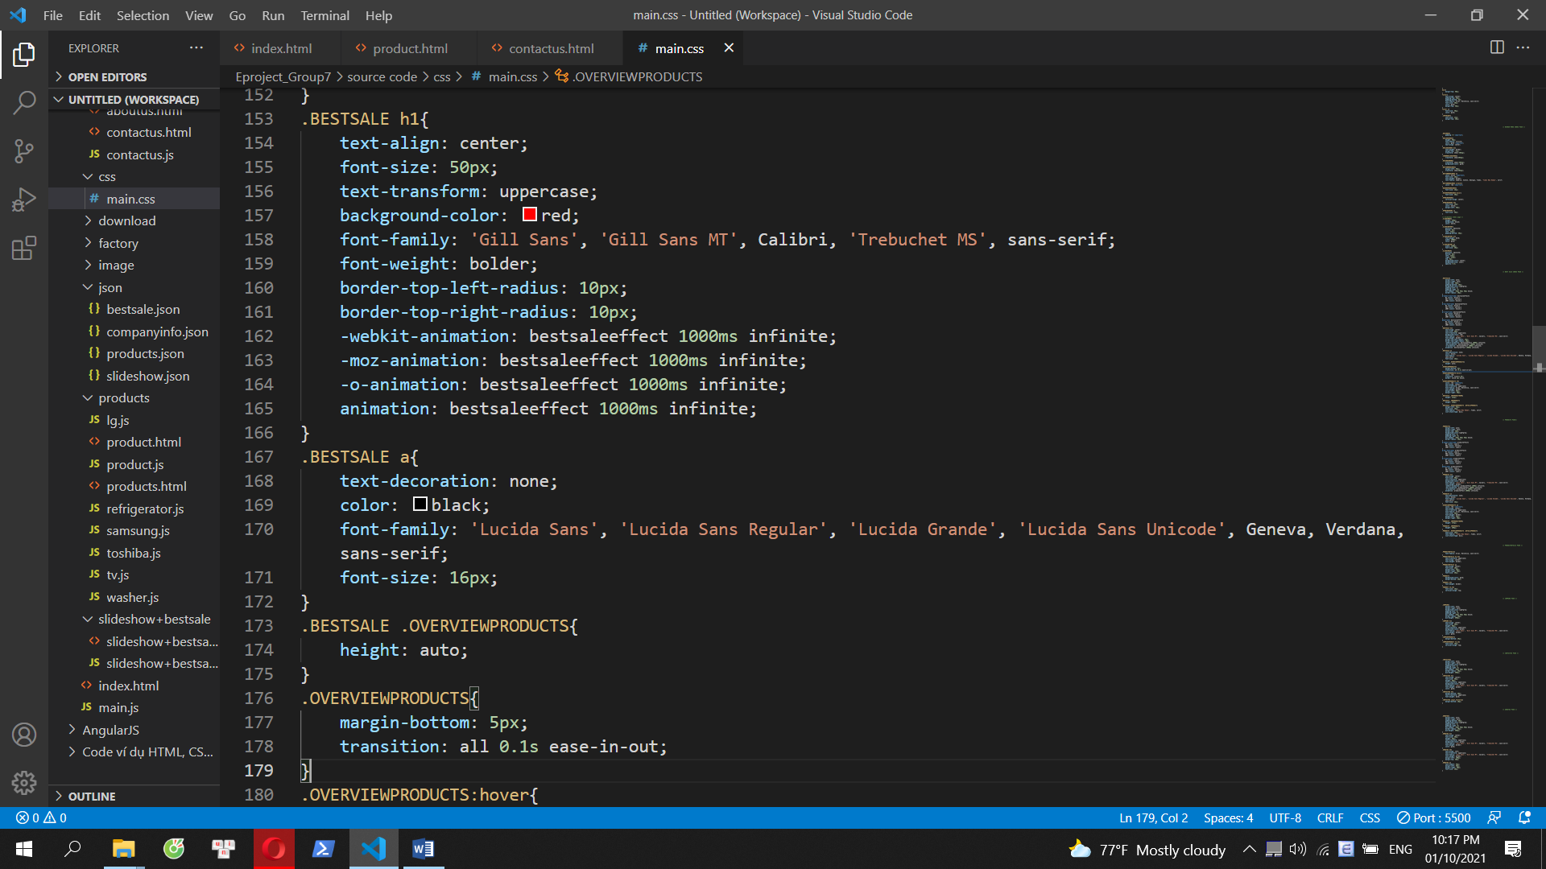

**main.css**

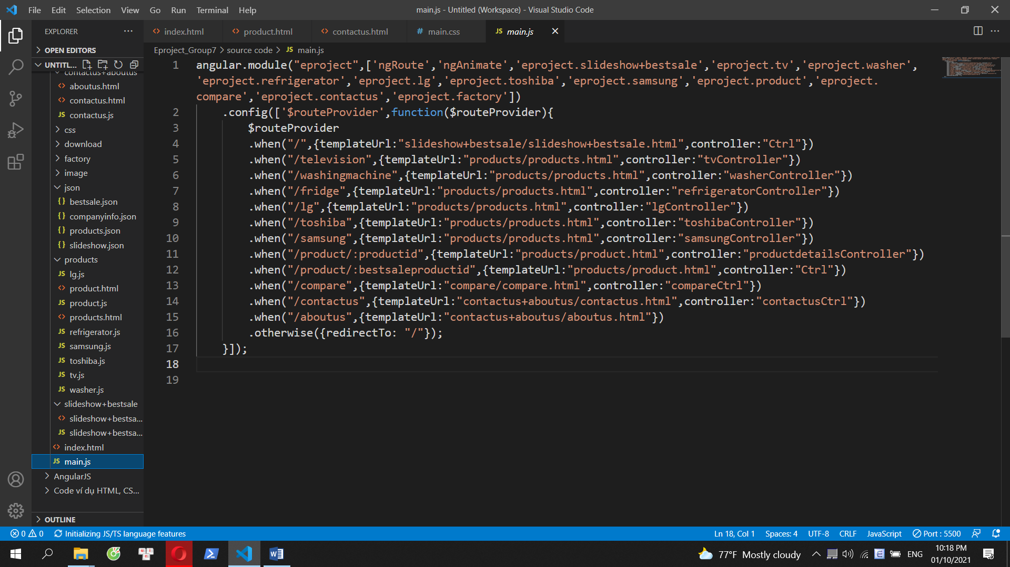

**main.js**

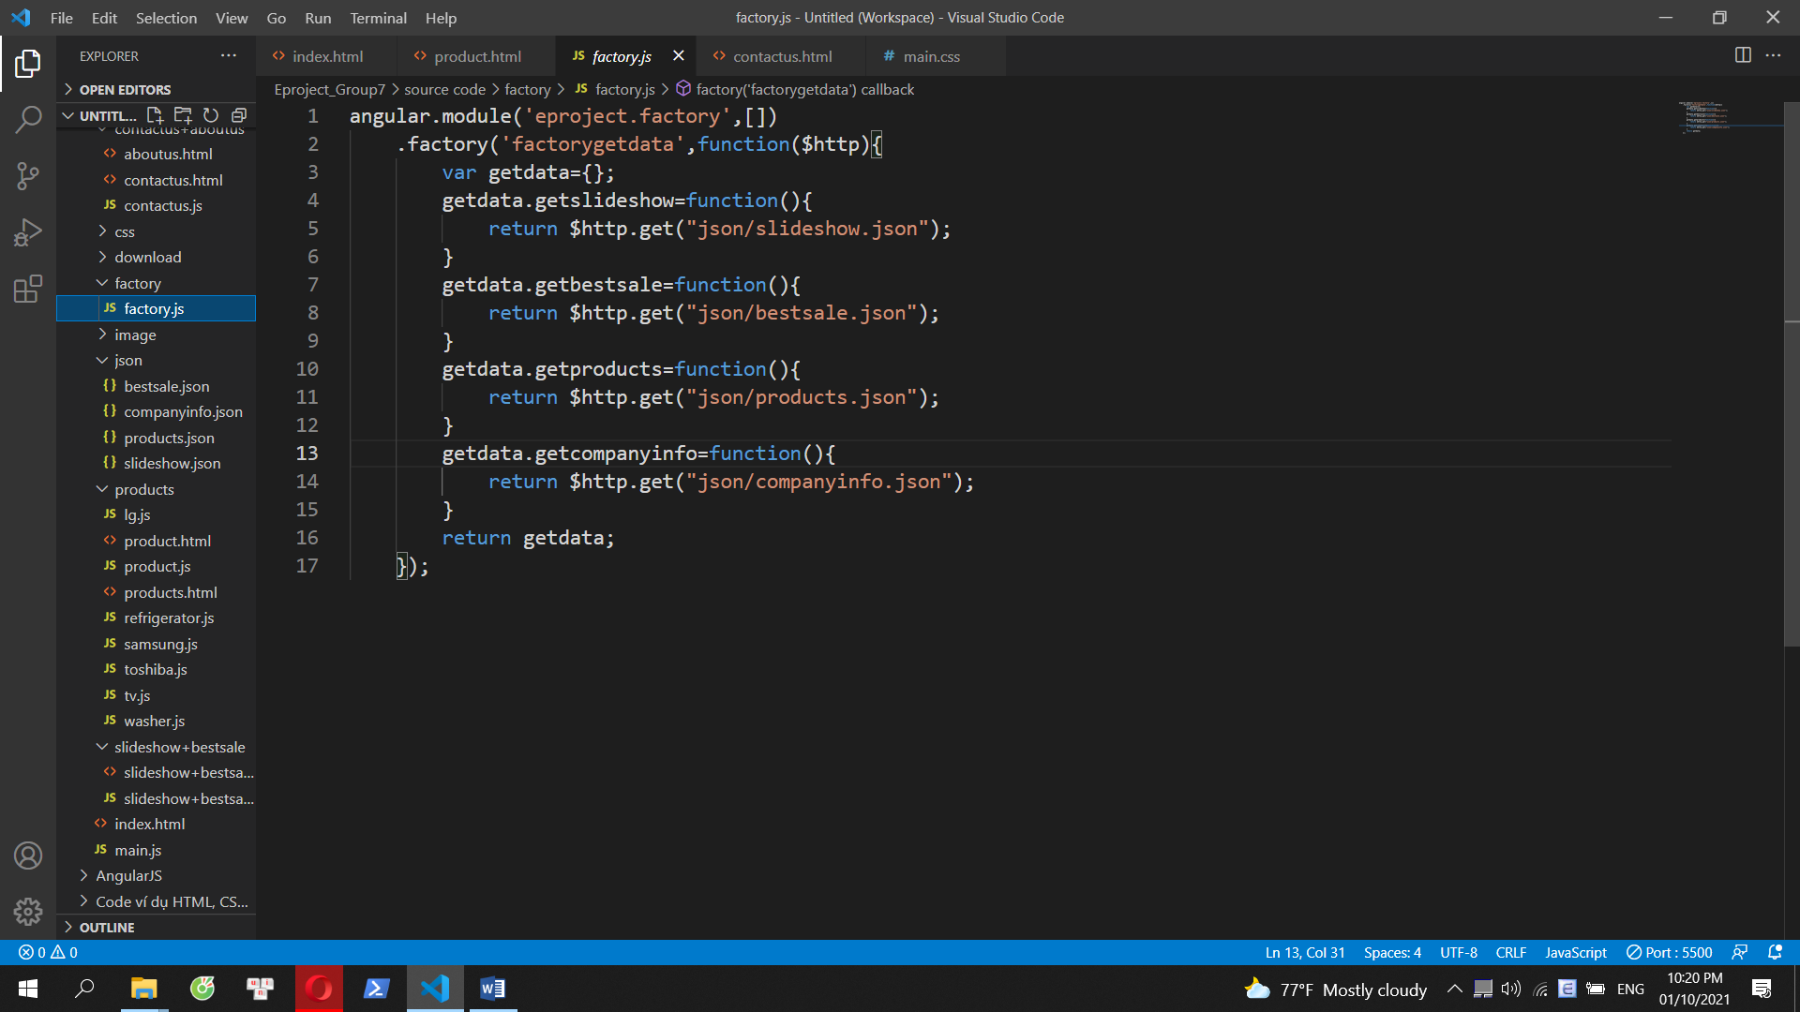

**factory.js**

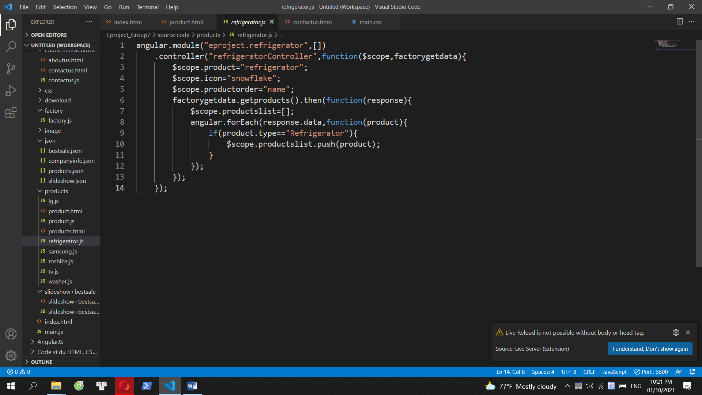

**One of the js files to control modules**

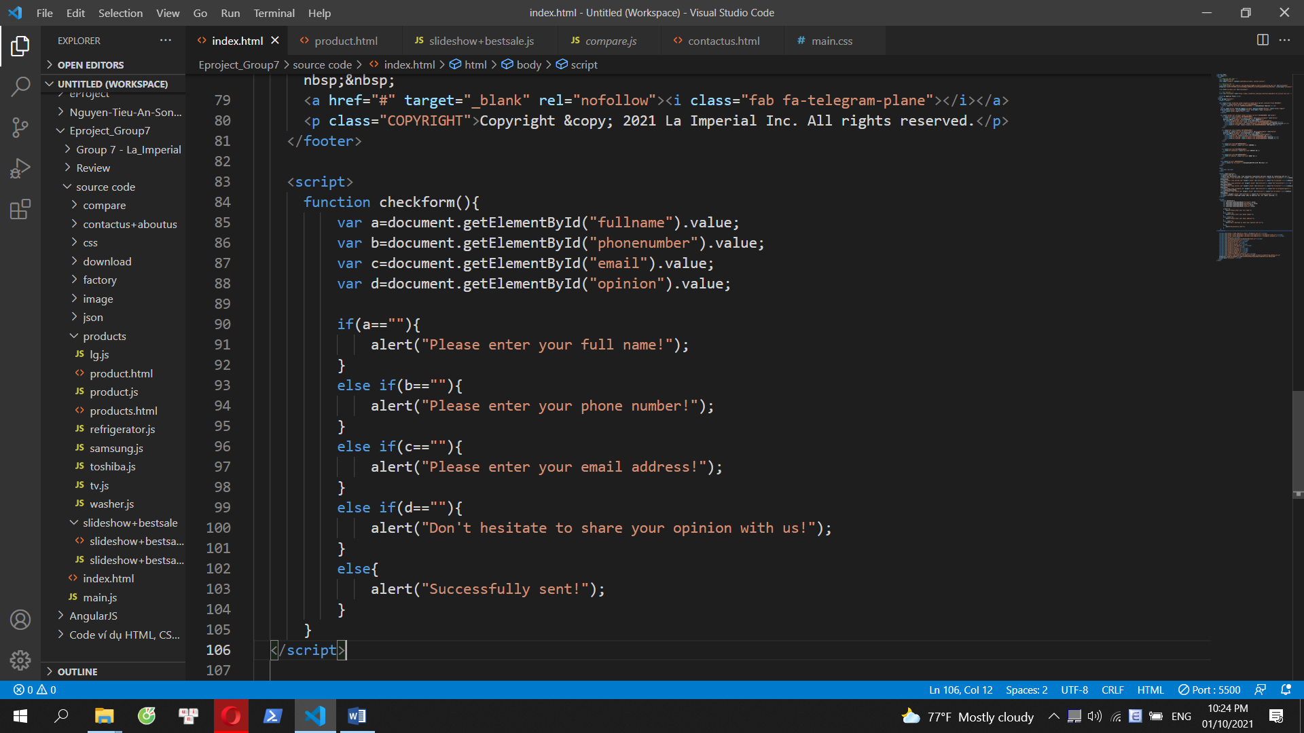

**Javascript**

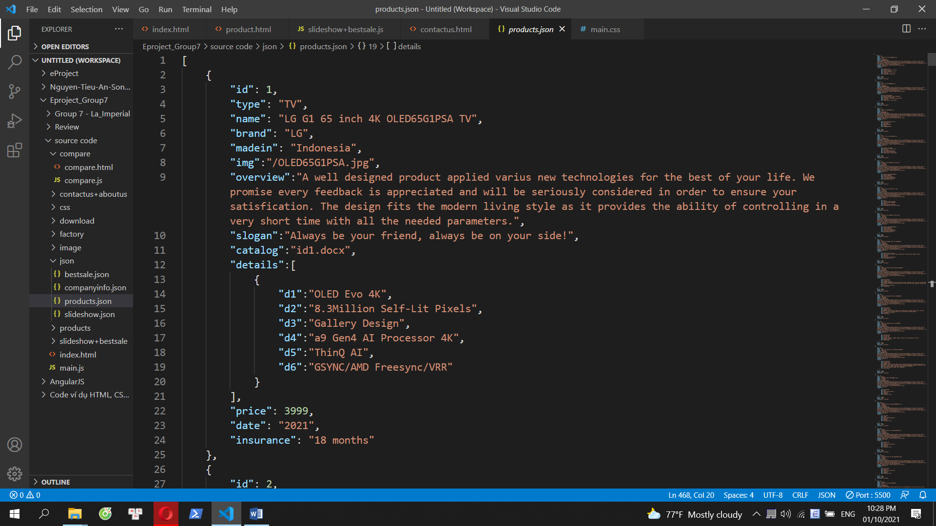

**json file**

# TASK SHEET REVIEW 3

|  |  |  |  |  |  |  |  |
| --- | --- | --- | --- | --- | --- | --- | --- |
| **Project Ref. No.:**  **eP/Advertisement**  **Portal Management System/01** | | **Project Title:** | **Activity Plan Prepared By:** | **Date of Preparation of Activity Plan:** | | | |
| **Sr.**  **No.** | **Task** | **Actual**  **Start Date** | **Actual Days** | **Team**  **Mate Names** | **Status** |
| 1 | Home page | La Imperial | Thinh | 27-Sep-2021 | 1 | Thinh | Completed |
| 2 | Products | 27-Sep-2021 | 1 | Thinh | Completed |
| 3 | Brands | 27-Sep-2021 | 1 | Thinh | Completed |
| 4 | Compare | 27-Sep-2021 | 1 | Thinh | Completed |
| 5 | Contact us | 27-Sep-2021 | 1 | Chau | Completed |
| 6 | About us | 27-Sep-2021 | 1 | Hieu | Completed |
| 7 | json | 27-Sep-2021 | 1 | Chau, Hieu | Completed |
| 8 | Task sheet | 30-Sep-2021 | 1 | Thinh | Completed |

|  |  |
| --- | --- |
| **Date: 02/10/2021** | |
| Signature of Instructor:  **Mr. Nguyen Phat Tai** | Signature of Team Leader:  **Mr. Vu Duc Thinh** |